

Faculty of Engineering and Applied Science

Software Project Management

Laboratory 4: Risk Mitigation, Resources Allocation, and Project Management

Date:  3/18/2020

Hoang Vu 100675262

Ming Lau 100623165

Armando Cuesta Leyva 100652479

*From lab 3*

*Activity Planning*

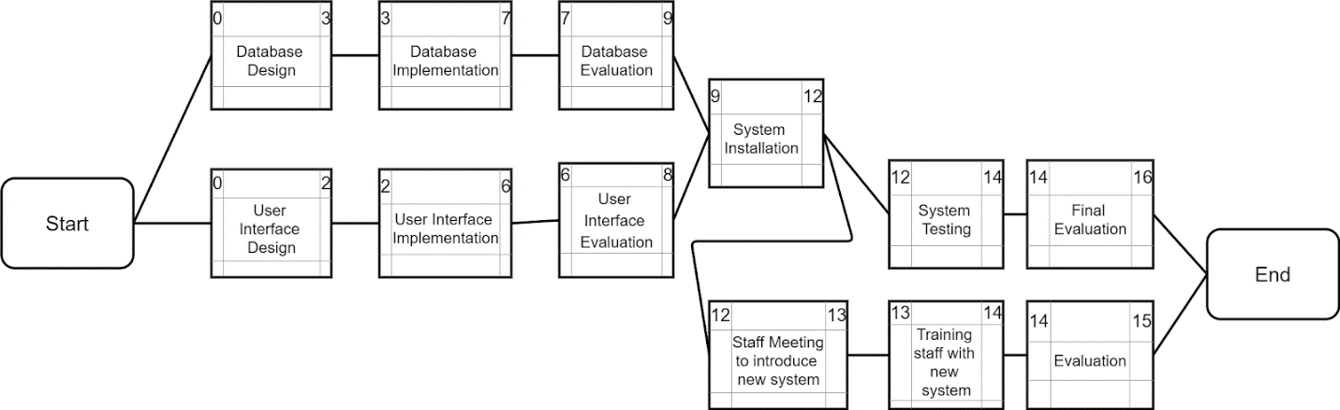

Figure : The Activity in Weeks

*Risk Management*

1.      Design risk

Some of the design or content may fail to meet requirements or may be rejected by stakeholders. In that case, we need to reach a consensus with our customers before implementing the application.

2.      Technology risk

Such as the connection outages that disrupt the service. To avoid this problem, we have to make a backup plan which is about our contingency measures.

*Lab 4*

**Risk and Counter Measures**

In the Design Phase there will be two activities being done, to complete the design task as needed. These two activities will ensure we implement a well thought out design of the iPad Restaurant Menu software application we are designing. The first task is to design its database. On the other side of the project the User Interface is being design. This phase will cover the back end and front end of the system. With the design phase planned out for the duration of 2-3 days, there are some risk going forward in this process of this project. One of the risks relates to the design of our product.

**Design Risk**

This Design Risk discussed on among the team members, brings some concerns. The concerns are that the design or content, that the team has created may end up failing to meet those requirements stated during the project initial stages. If that is not the case it could be that even with those requirements met the stakeholders might not be satisfied with the overall design produced by our team. If these cases of the design risk have a good chance of occurring, the team has agreed upon reaching a consensus with our customers before, during, and after the design phase. The important thing is to make it feel like a prototype rather than the actual product, to get their constructive feedbacks. If the approach is done right, and to them it does feel like a prototype, we can avoid losing potential clients that could even help in funding the project. Success in this counter measure will ensure the success of the end state of the project and product allowing the business to gain a good reputation and a good software application that can be used for decades to come.

**Technology Risk**

Continuing with the design phase and same activities, there is another concern that needed to be addressed. This risk concerns itself with the technology being used for the blueprints of this Restaurant Application. And so, the group got together and agreed upon the severity of this potential risk. With that, we decided that it had precedence over the other risk that could be had with the process of this project. The risk looked at common occurrence with technology in our daily lives. One brought that power outages can happen. Another brought that connection issues can happen. The group continued talking about a bunch of issues that could pose potential risks to our software in the open world. With these problems we brought counter measures. One of our countermeasures, for example is to simply avoid the event, to accomplish this our course of action would be to implement a backup power supply.

**Resources**

**The Resources:**

1. **Member 1: The system analyst and tester (Hoang Vu along with his provided teams)**
2. **Member 2: The project director and designer (Armando Cuesta Leyva along with his provided teams)**
3. **Member 3: The implementor and documenter (Ming Lau along with his provided teams)**
4. **Member 4: The Team (the team to work with)**

**Hoang** will have the role in this project to analyze everything related to the system of this software, and if required, make the necessary tests to it to ensure good quality software. He will be put in charge of two teams to help run the operation.

**Armando** will have the role in this project to guide and supervise everything within this project, and make the designs needed to implement the software. He will be put in charge of two teams to make those needed decisions.

**Ming** will have the role in this project to document everything needed to be presented to the stakeholders about this software and implement the design provided from the design phase. He will be put in charge of a team of programmers and make sure they implement as well as document their codes.

**Project Management**

**The Project Planning**

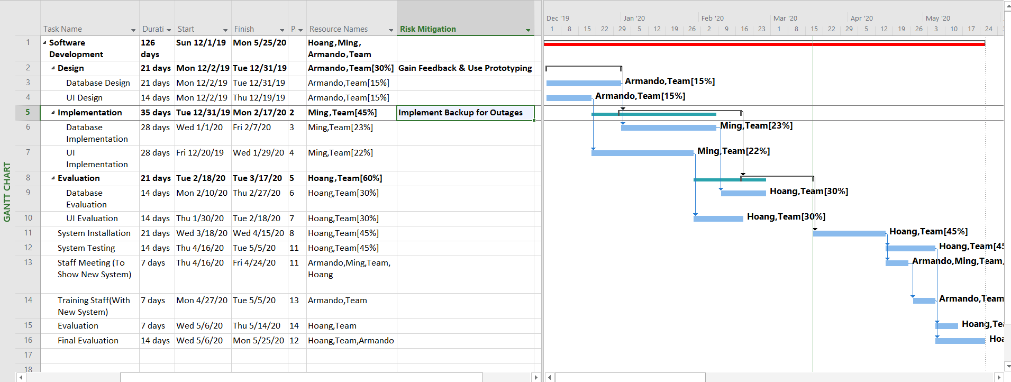

Figure : Will take around 4 months to complete